Get the Image Segmentation Database

Installing the COCO API

http://cocodataset.org/#home

There is a COCO api available at on Github
https://github.com/cocodataset/cocoapi
clone the repo to your computer
$ git clone https://github.com/cocodataset/cocoapi.git
$ cd cocoapi/PythonAPI
-For Python, run "make" under coco/PythonAPI

$ make

Add the cocoapi/PythonAPI path to python by opening .profile and inserting the following:
# add cocoapi to python path
export PYTHONPATH=/home/jeff/Documents/cocoapi/PythonAPI:$PYTHONPATH

Test this worked by restarting computer, opening python and running the command:
>>> from pycocotools.coco import COCO

Download COCO images and annotations
- Navigate to coco website and download all 2017* data links (this will take a while). (Note: At this time the Unlabeled Images are Unlabeled Image Info are not necessary to download)
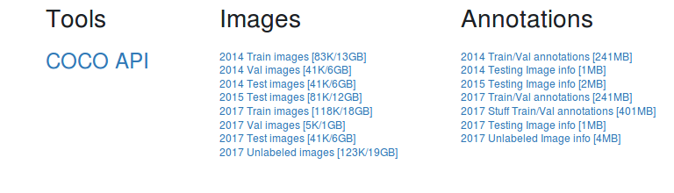
- Follow the instructions from the github page for the cocoapi
In addition to this API, please download both the COCO images and annotations in order to run the demos and use the API. Both are available on the project website.
-Please download, unzip, and place the images in a directory with the following structure:

./coco/images/

-Please download and place the annotations in another folder in that same location called:
coco/annotations/
Drop the entire unziped folders into the directories above

Test the COCO API
Using Jupyter Notebook, open the file called COCO_api_demo.ipynb
Change the path to the data set to your specified path such as:
dataDir='/home/jeff/Documents/coco/'

